Angular – Pipes

What are Angular Pipes?
In Angular, pipes are functions that format specified data before displaying it in the View. They help to transform and manage data within interpolation, denoted by {{ | }}. Therefore, pipes are sometimes referred to as filters. It accepts arrays, integers and strings as inputs which are separated by a vertical bar "|" symbol.


Features and Uses of Angular Pipes
Some of the features and uses of Angular pipes are listed below:
- Pipes can apply transformations directly within the HTML element.
- Once a custom pipe is created, it can be reused throughout the Angular application.
- Multiple pipes can be chained together. The output of one pipe can be passed as input to another pipe.
- You can use pipes to format and transform numbers, objects, strings, and dates in a way that is suitable for display in the UI.
- Pipes are used to filter data which means it can show only certain items from a list based on passed conditions.

How to Use Angular Pipes?
To use Angular pipes in your application, embed the pipe directly inside template expression. This is done using Angular's pipe operator which is denoted by a vertical bar character "|".

The pipe operator is a binary operator. On the left of this operator, the input value is passed to the transformation function, and the right-side operand is the pipe name.
All the built-in pipes in Angular are available in the @angular/common package. Hence, make sure to import the required pipe from this package by specifying the pipe name in the following command:
import { Pipe-Name } from '@angular/common';

Syntax
The syntax to use Angular pipe is as follows:
<html-tag-name>{{ input-value | pipe-name }}</html-tag-name>
Where html-tag-name can be replaced by any HTML tag, input-value is the input that will be passed into the pipe on the right side of pipe operator.

Chaining Angular Pipes
Chaining multiple pipes together is also possible. The output of one pipe can be passed as input to another pipe. And, the chained pipes run from left to right.
The syntax to chain Angular pipes is as follows:
<html-tag-name>{{ input-value | pipe1 | pipe2 }}</html-tag-name>

Passing Parameters to Angular Pipes
Some Angular pipes allow to configure the transformation by passing parameters. To specify a parameter, append the pipe name with a colon (:) followed by the parameter value.
The syntax to add parameters to Angular pipes is shown below:
<html-tag-name>{{ input-value | pipe : parameter }}</html-tag-name>

Working Example
The following example illustrates how to use the DatePipe in your Angular application to format dates.
- Create a pipe-app application
  - Open command window with admin right
  - Run commands:
    - cd\
    - ng new pipe-app (Use all default settings)
    - cd pipe-app
    - code .
  - Close the command window. The VS Code now is open for the project folder.
- In the app.ts file:
import { Component, signal } from '@angular/core';
import { RouterOutlet } from '@angular/router';
import { DatePipe} from '@angular/common';

@Component({
selector: 'app-root',
imports: [RouterOutlet, DatePipe],
templateUrl: './app.html',
styleUrl: './app.css'
})
export class App {
protected readonly title = signal('pipe-app');
presentDate = new Date();
}
- Change the content in app.html file:
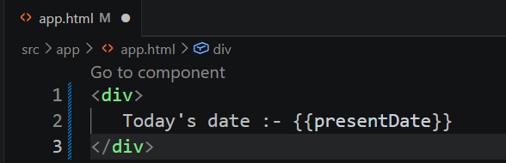
- In Terminal window run command ng serve --open
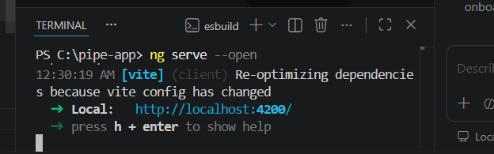
You should the browser open the web application
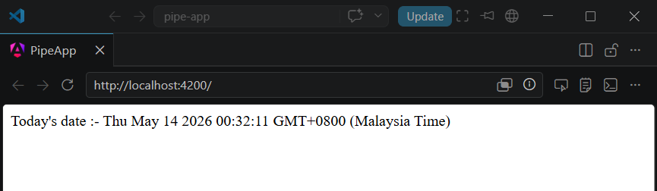
- Let's add date pipe in the app.html file
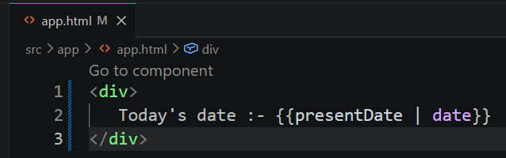
After app.html is saved, browser should show
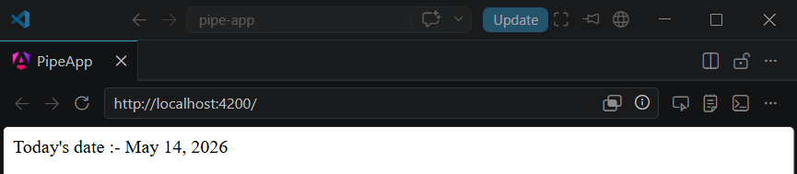
- Pass fullDate parameter to the date pipe as shown below:
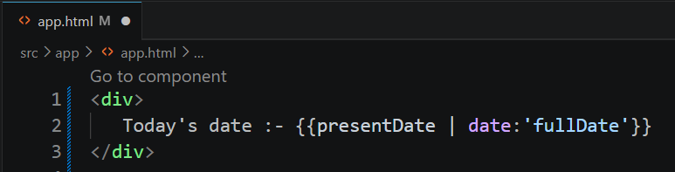
After app.html is saved, browser should show
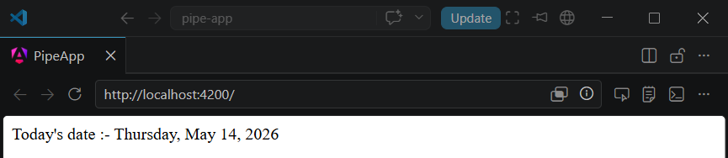
Note: Leave this project active. We will use it for Custom Pipe late

Angular - Built-In Pipes
Some of the important Angular built-in pipes are given below:
DatePipe | It is used to format a given date value.
UpperCasePipe | It converts individual letters of the specified texts into uppercase.
LowerCasePipe | It transforms individual letters of the specified texts into lowercase.
CurrencyPipe | This pipe is used to transform a given number into a currency string.
DecimalPipe | This pipe formats a number into a string of decimal point number.
PercentPipe | It formats specified numbers into a percentage string.
TitleCasePipe | It is used to convert the specified text to a title case.
JsonPipe | This built-in pipe is used to transform an object to its corresponding JSON string representation.
KeyValuePipe | Use this pipe to create an array of key-value pairs from a given object or map.
SlicePipe | It returns a new sub-string from the specified string.

Official reference: https://angular.dev/guide/templates/pipes#

Angular Custom Pipes
A custom pipe is a user-defined pipe that allows developers to perform specific transformations that Angular's built-in pipes can't achieve. The built-in pipes provide limited functionalities like formatting dates, numbers and strings. However, you can achieve more than that using custom pipes. For example, sorting and filtering.
Features and Uses of Angular Custom Pipes:
- Once you define a custom pipe, you can reuse it wherever needed in the application.
- Like built-in pipes, custom pipes can also be used directly in the template expressions.
- The logic for custom pipes is written in a separate TypeScript class and applied within the template. This helps in maintaining the code and improving the performance.
- There are a number of features that you can add using custom pipes to your Angular application, such as digit count, filtering, sorting, password generation and many more.

Creating a Custom Pipe in Angular
Follow the steps given below to create a Custom pipe in Angular:
- Create a TypeScript class and export it. By convention, a pipe class should end with the string "Pipe".
- Decorate the created TypeScript class with @Pipe Decorator. Inside this decorator, specify a name for the pipe.
- In the end, inherit the PipeTransform interface and implement its transform() method.

Working Example
- Rename the Terminal of the previous app-pipe project as “Server”.
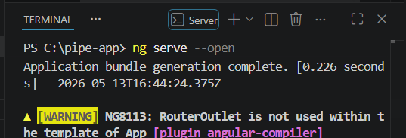
- Start a new Terminal
- Run ng g pipe digitcount from new terminal
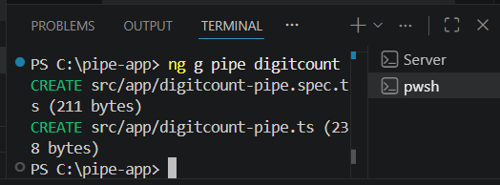
After executing the above command, you can see these two files
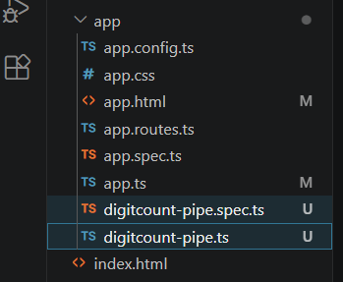
- Let's create a logic for counting digits in a number using Pipe. Open digitcount.pipe.ts file and add the below code
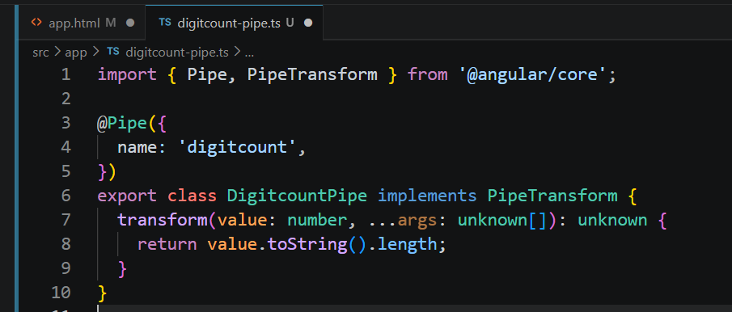
- Create a new attribute and import the custom pipe in app.ts
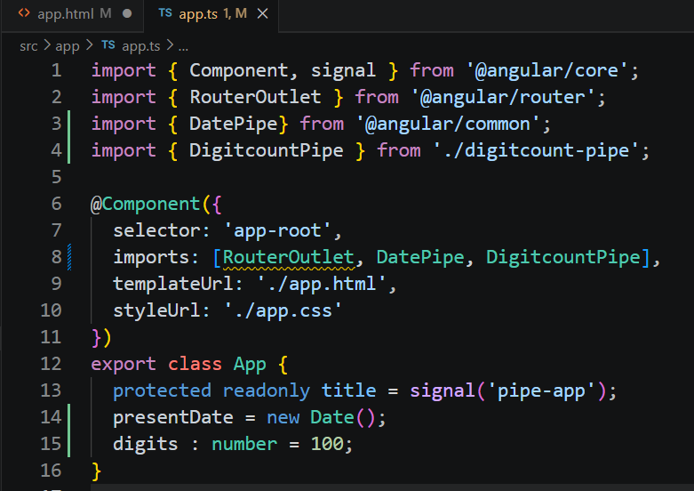
- Add script to test the pipe result in app.html
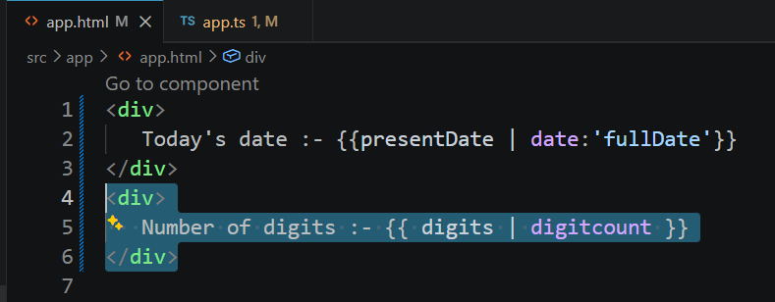
After app.html is saved, browser should show
